SENIOR YEAR END PROCESSING IN SCHOOLINKS
THIS TASK IS REQUIRED FOR ALL SENIORS, even if you are not planning to enroll in a school. This task is due on THURSDAY May 14th. It takes 2 minutes to complete! Completing this task will automatically clear the “Set Up Personal Account for Alumni Access” task.

Why is this task important?
- Completing this task requests a final transcript to be sent to the institution you are planning to attend.
- If you are going to a community college in the summer and going somewhere else in the Fall, this task allows you to request a transcript to be sent to BOTH institutions.
- If you are not planning to enroll in school for the summer or fall, completing this task gives you the ability to login to SchooLinks later to request a transcript.
- Senior Walk: This will save you time and skip the long line to get your cap & gown on the morning of 5/18! Your cap & gown are ON HOLD until this task is completed.

The screenshots below provide guidance on how to access this task in SchooLinks:

- Login to SchooLinks and find your To Do List on your Home page. 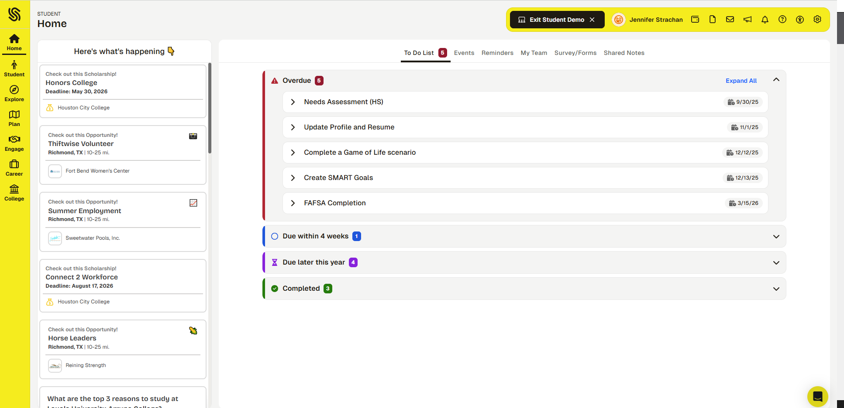

- Click on “Due within 4 weeks” to reveal the Senior Year End Activity.
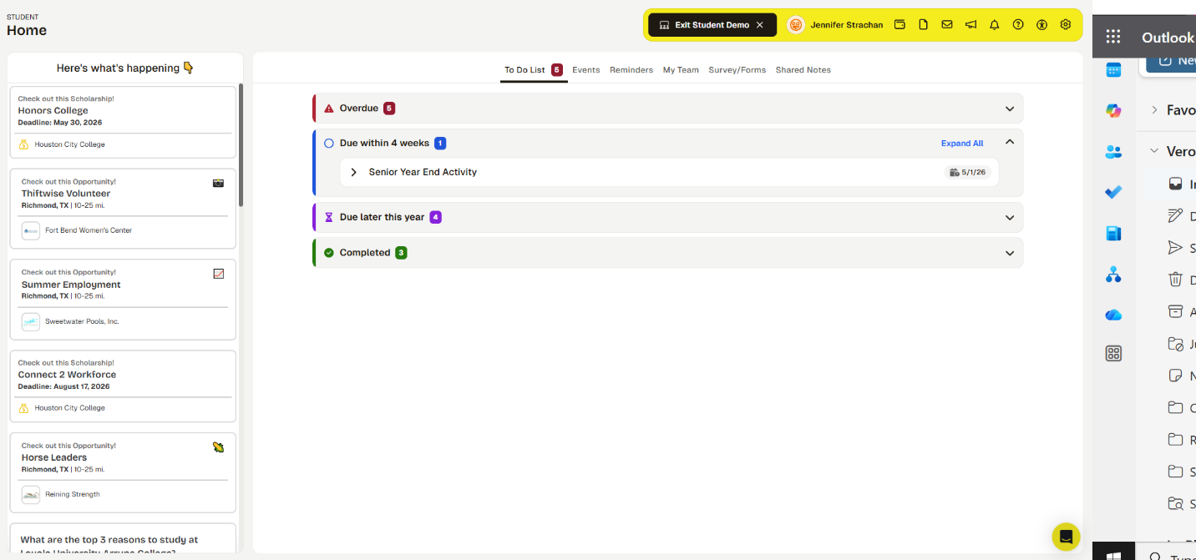

3. Click on “Senior Year End Activity” and click “Go to feature” to start answering the prompts required for this task.
